**Dog and Bone**

1. Delete Sprite 1 (the cat) from the stage.
2. Add a Dog sprite to the stage (I used Dog2).

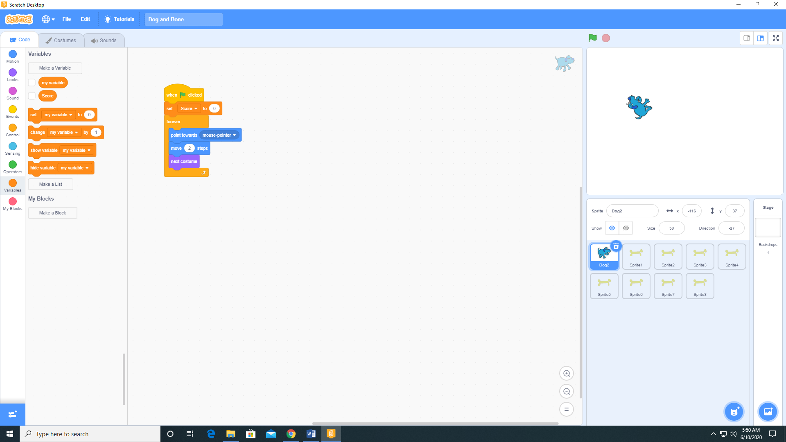

1. Paint a bone sprite and add to the stage.

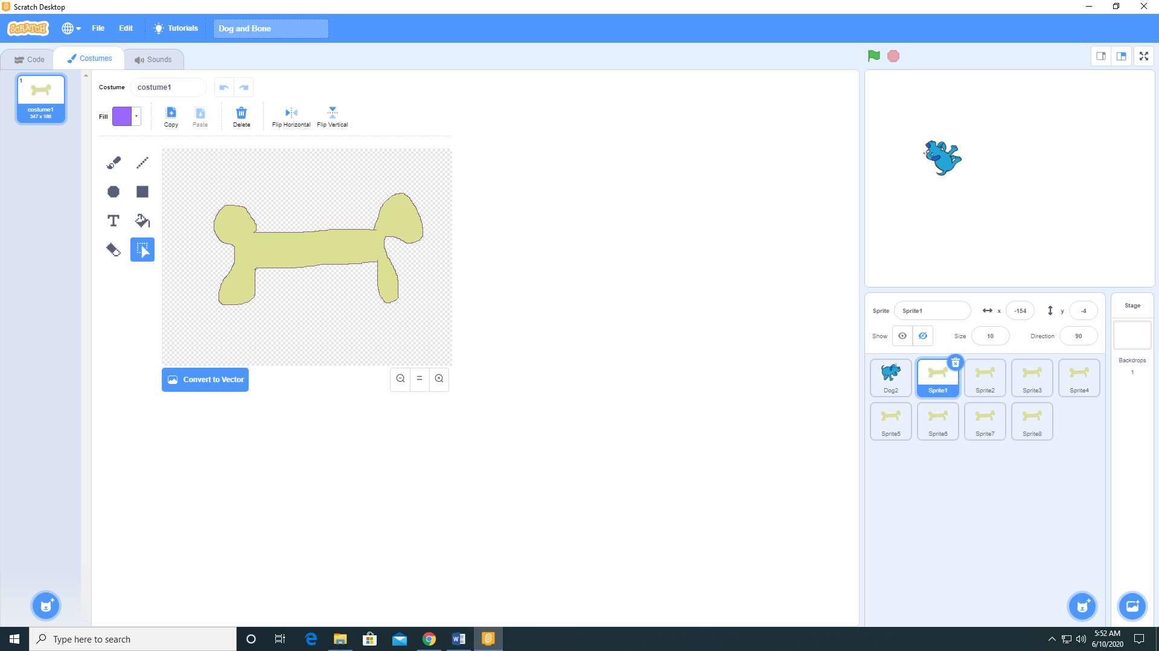

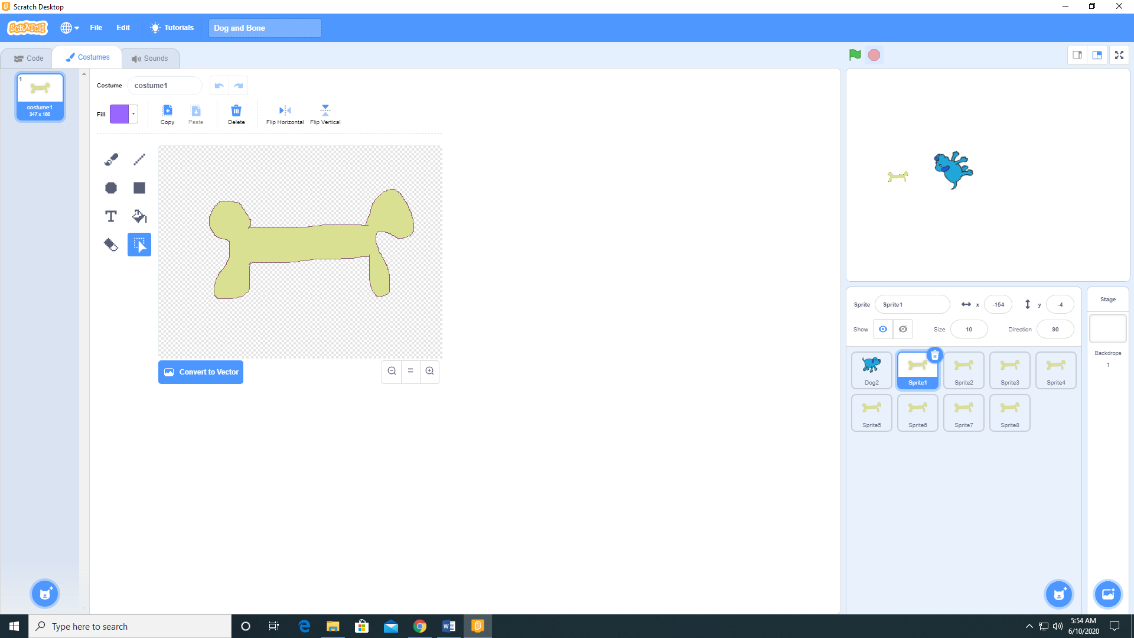

1. Make a variable Score and check the checkbox next to it.

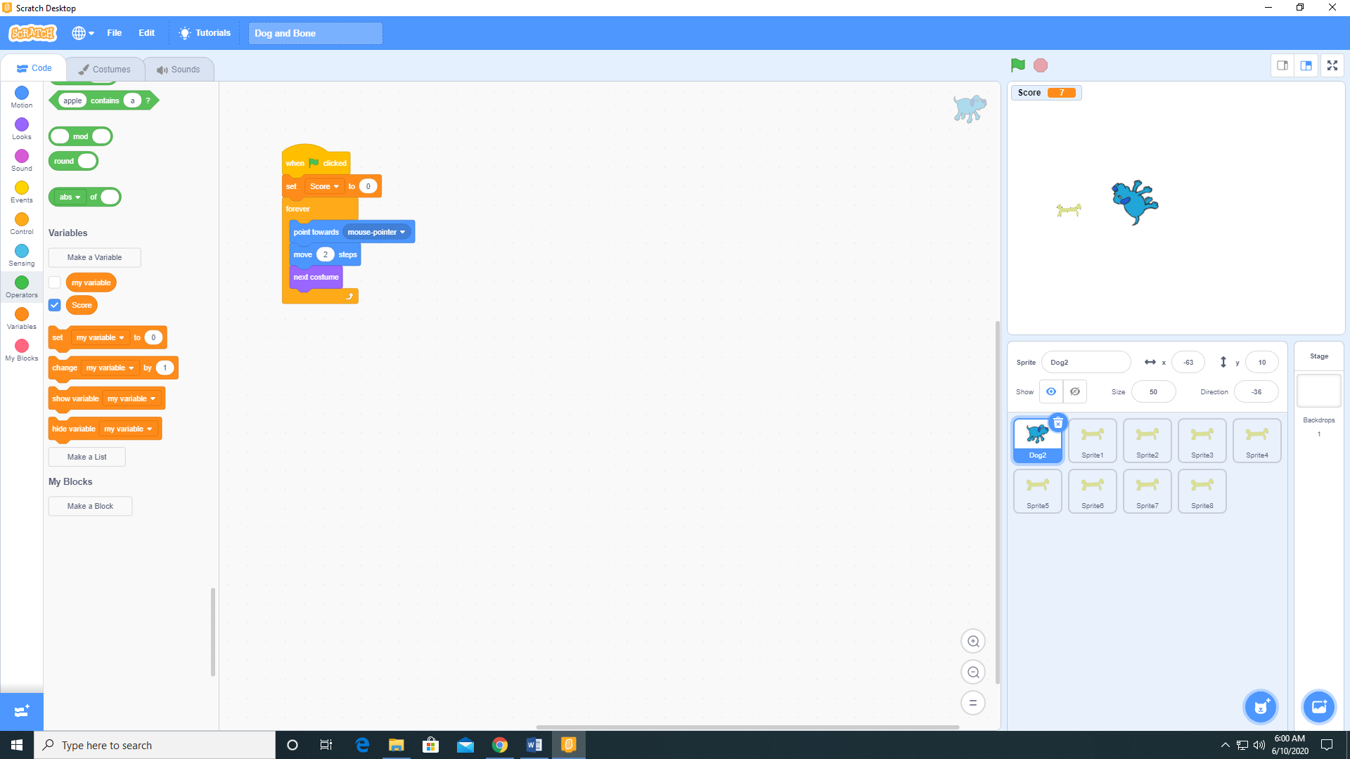

1. Add the following code to the Dog 2 sprite.

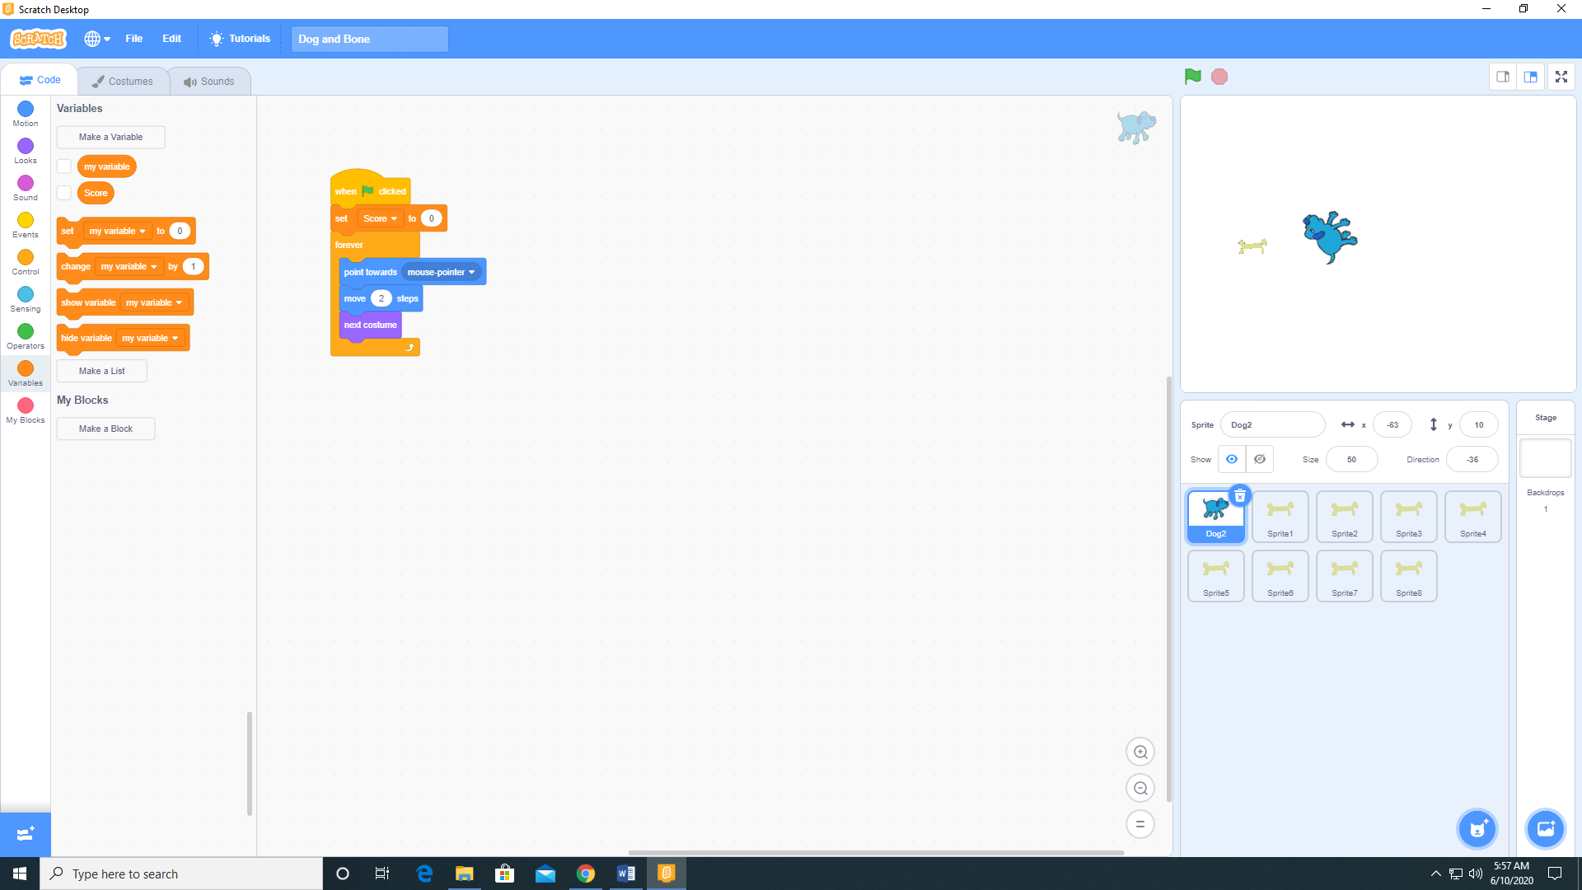

1. Add the following code to Sprite 1 (the bone).

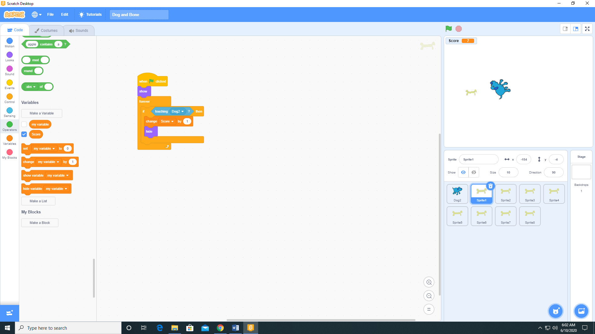

1. Duplicate Sprite 1 several times and distribute them around the stage.

